Nithin S
221IT085

Q1) Implement Binary Search using linked lists and Array.

#include<stdio.h>
#include<stdlib.h>
#include<stdbool.h>
#include<string.h>

struct Node
{
int data;
struct Node *next;
};

void insertLast(struct Node **head,int x)
{
struct Node* temp=(struct Node*)malloc(sizeof(struct Node));
temp->data=x;
temp->next=NULL;
if(*head==NULL) *head=temp;
else
{
struct Node *p=*head;
while(p->next)
{
p=p->next;
}
p->next=temp;
}

}

struct Node* findMiddle(struct Node*head,struct Node*end)
{
if(head==NULL) return NULL;
struct Node *fast=head->next;
struct Node *slow=head;
while(fast!=end)
{
fast=fast->next;
if(fast!=end)
{
fast=fast->next;
slow=slow->next;
}
}
return slow;
}

void display(struct Node *p)
{
while(p)
{
printf("%d ",p->data);
p=p->next;
}
}

struct Node* binarySearch(struct Node*head,int key)
{
struct Node*first=head;
struct Node*last=NULL;
do
{
struct Node* mid=findMiddle(first,last);
if(mid==NULL) return NULL;
if(mid->data==key) return mid;
else if(mid->data>key) last=mid;
else first=mid->next;
} while (last==NULL||last!=first);
return NULL;
}

bool binarySearchArray(int arr[],int key,int n)
{
int start=0;
int last=n-1;
while(start<=last)
{
int mid=(start+last)/2;
if(arr[mid]==key) return true;
else if(arr[mid]>key) last=mid-1;
else start=mid+1;
}
return false;

}

int main()
{
int n=0;
int key=0;
char choice;
printf("Do you want to search in an Array(A) or linkedList(L).Enter 'L' or 'A': ");
scanf("%c",&choice);
if(choice=='L')
{
struct Node *ll1=NULL;
printf("Enter the No. of elements in the linked list: ");
scanf("%d",&n);
printf("Enter the elements (Integers) seperated by spaces: ");
while(n>0)
{
int num=0;
scanf("%d",&num);
insertLast(&ll1,num);
n--;
}
printf("The entered linkedList: ");
display(ll1);
printf("\nEnter an element to search: ");
scanf("%d",&key);
if(binarySearch(ll1,key)==NULL) printf("%d is not present in the linkedList.\n",key);
else printf("%d is present in the linkedList.\n",key);
return 0;
}
else if(choice=='A')
{
printf("Enter the No. of elements in the array: ");
scanf("%d",&n);
int *arr=(int*)malloc(sizeof(int)*n);
printf("Enter the elements seperated by spaces: ");
for(int i=0;i<n;i++)
scanf("%d",&arr[i]);

printf("The Array contains: ");
for(int i=0;i<n;i++)
printf("%d ",arr[i]);
printf("\nEnter the element to be searched: ");
scanf("%d",&key);
if(binarySearchArray(arr,key,n)) printf("%d is present in the linkedList.\n",key);
else printf("%d is not present in the linkedList.\n",key);
}
else
{
printf("Invalid Choice");
return 0;
}
}

OUTPUT

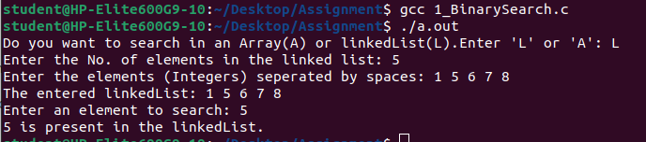
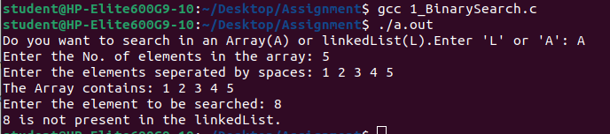
Q2) Implement Stack using Array

#include<stdio.h>
#include<stdlib.h>
#include<stdbool.h>
#define MAX_SIZE 100

int top = -1;
int stack[MAX_SIZE];

void push(int x)
{
if(top == MAX_SIZE - 1)
{
printf("Stack Overflow.\n");
return;
}
else
{
top++;
stack[top] = x;
}
}

int pop()
{
if(top == -1)
{
printf("Stack Underflow.\n");
exit(1);
}
return stack[top--];
}

bool isEmpty()
{
return (top == -1);
}

void display()
{
for(int i = 0; i <= top; i++)
printf("%d ", stack[i]);
printf("\n");
}

int main()
{
char choice;
int num;

while(1)
{
printf("Enter:\n1 to Push, 2 to Pop, q to Quit\n");
scanf(" %c", &choice);

if(choice == 'q')
{
break;
}
else if(choice == '1')
{
printf("Enter the element to push: ");
scanf("%d", &num);
push(num);
printf("Stack : ");
display();
}
else if(choice == '2')
{
pop(num);
printf("Stack : \n");
display();
}
else
{
printf("Invalid choice. Try again.\n");
}
}

return 0;
}

OUTPUT
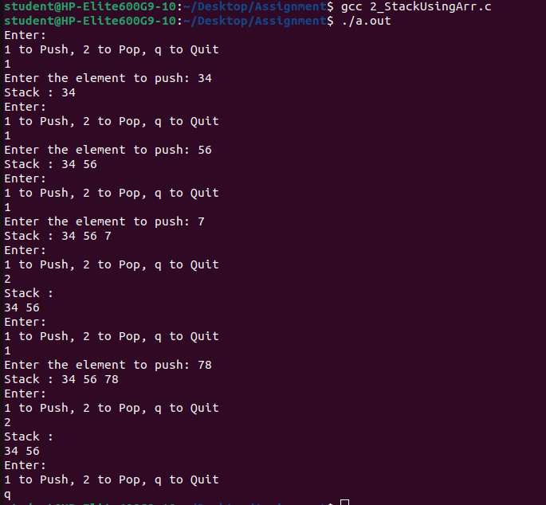

Q3) Write a program to reverse a linked list

#include<stdio.h>
#include<stdlib.h>

struct Node
{
int data;
struct Node *next;
};

void insertLast(struct Node **head,int x)
{
struct Node* temp=(struct Node*)malloc(sizeof(struct Node));
temp->data=x;
temp->next=NULL;
if(*head==NULL) *head=temp;
else
{
struct Node *p=*head;
while(p->next)
{
p=p->next;
}
p->next=temp;
}

}

struct Node* reverse(struct Node *p)
{
struct Node *r=NULL,*q=NULL;
while(p)
{
r=q;
q=p;
p=p->next;
q->next=r;
}
return q;
}

void display(struct Node *p)
{
while(p)
{
printf("%d ",p->data);
p=p->next;
}
}

int main()
{
int n=0;
struct Node *ll1=NULL;
printf("Enter the No. of elements in the linked list: ");
scanf("%d",&n);
printf("Enter the elements seperated by spaces: ");
while(n>0)
{
int num=0;
scanf("%d",&num);
insertLast(&ll1,num);
n--;
}
printf("The entered linkedList before reversal: ");
display(ll1);
printf("\nThe entered linkedList after reversal: ");
ll1=reverse(ll1);
display(ll1);
return 0;
}

OUTPUT

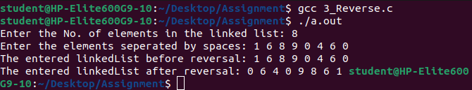

Q4 ) Write a function to check if a linked list is palindrome or not?

#include<stdio.h>
#include<stdlib.h>
#include<stdbool.h>

struct Node
{
int data;
struct Node *next;
};

void insertLast(struct Node **head,int x)
{
struct Node* temp=(struct Node*)malloc(sizeof(struct Node));
temp->data=x;
temp->next=NULL;
if(*head==NULL) *head=temp;
else
{
struct Node *p=*head;
while(p->next)
{
p=p->next;
}
p->next=temp;
}

}

struct Node* reverse(struct Node *p)
{
struct Node *r=NULL,*q=NULL;
while(p)
{
r=q;
q=p;
p=p->next;
q->next=r;
}
return q;
}

struct Node* findMiddle(struct Node*head)
{
struct Node* fast=head->next;
struct Node* slow=head;
while(fast && fast->next)
{
slow=slow->next;
fast=fast->next->next;
}
return slow;
}

void display(struct Node *p)
{
while(p)
{
printf("%d ",p->data);
p=p->next;
}
}

bool isPalindrome(struct Node*head)
{
struct Node* mid=findMiddle(head);
struct Node* p=head;
struct Node* q=mid->next;
mid->next=NULL;
q=reverse(q);
while(p && q)
{
if(p->data!=q->data)
{
return false;
}
p=p->next;
q=q->next;
}
return true;
}

int main()
{
int n=0;
int key=0;
struct Node *ll1=NULL;
printf("Enter the No. of elements in the linked list: ");
scanf("%d",&n);
printf("Enter the elements seperated by spaces: ");
while(n>0)
{
int num=0;
scanf("%d",&num);
insertLast(&ll1,num);
n--;
}
printf("The entered linkedList: ");
display(ll1);
if(isPalindrome(ll1)) printf("\nIt is a Palindrome.");
else printf("\nIt is not a Palindrome.");
return 0;
}

OUTPUT
